Exercise 1:

Write a C++ program, that ask user to enter 10 integer values. Store those values in one dimension array. Create an other one dimension array of same size, and store the values of first array in reverse order. Print the results on screen.

Your Program should display output as follows:

**#Sample Program Run#1**

**===================================**

**Matrix A – Original**

**===================================**

**12 23 25 4 6 8 2 7 9 11**

**===================================**

**Matrix A – Reverse**

**===================================**

**11 9 7 2 8 6 4 25 23 12**

**SOURCE CODE:**

#include<iostream>

using namespace std;

int main()

{

//Declaring arrays:

int arr1[10],arr2[10],b,a;

//enter values of array1:

cout<<"Please Enter 10 values of array 1:"<<endl;

for(a=0;a<=9;a++)

{

cin>>arr1[a];

}

//cout array1:

cout<<"========================"<<endl;

cout<<"Matrix A Original:"<<endl;

cout<<"========================"<<endl;

for(a=0;a<=9;a++)

{

cout<<arr1[a]<<" ";

}

cout<<"\n"<<"\n"<<"========================"<<endl;

cout<<"Matrix A Reverse:"<<endl;

cout<<"========================"<<endl;

//store values of array1 in array2 in reverse order:

for(a=0,b=9;a<=9;a++,b--)

{

arr2[b]=arr1[a];

}

//cout array2:

for(b=0;b<=9;b++)

{

cout<<arr2[b]<<" ";

}

return 0;

}

**SCREENSHOT:**

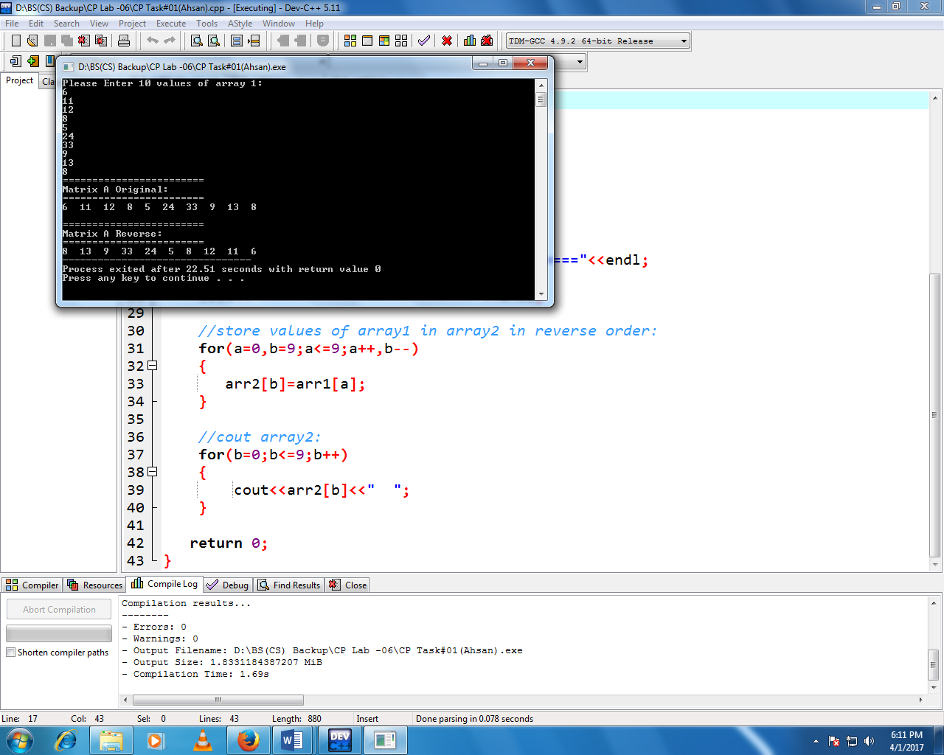

Exercise 2:

Write a C++ Program that checks whether the two arrays are equal or not.

Declare two Interger Arrays with 7 elements, and fill up the array with keyboard input.

Test if every element in Array 1 is equal to corresponding element in Array 2. For example, the program should check A[0] = B[0], A[0] = B[0], and so for.

Your Program should display output as follows:

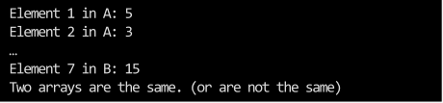

**SOURCE CODE:**

#include<iostream>

using namespace std;

int main()

{

//Declaring Arrays:

int arr1[7],arr2[7],a,b;

//Enter values of array1:

for(a=1;a<=7;a++)

{

cout<<"Enter Element "<<a<<" in A:";

cin>>arr1[a];

}

cout<<"\n"<<"\n";

//Enter values of array2:

for(b=1;b<=7;b++)

{

cout<<"Enter Element "<<b<<" in B:";

cin>>arr2[b];

}

//Comparing values of arr1 & arr2:

if(arr1[1]==arr2[1] || arr1[2]==arr2[2] || arr1[3]==arr2[3] || arr1[4]==arr2[4] || arr1[5]==arr2[5] || arr1[6]==arr2[6] || arr1[7]==arr2[7])

{

cout<<"\n"<<"Two Arrays are same:";

}

//If values of arr1 & arr2 are not same cout else statement:

else

{

cout<<"\n"<<"Arrays are not same:";

}

return 0;

}

**SCREENSHOT:**

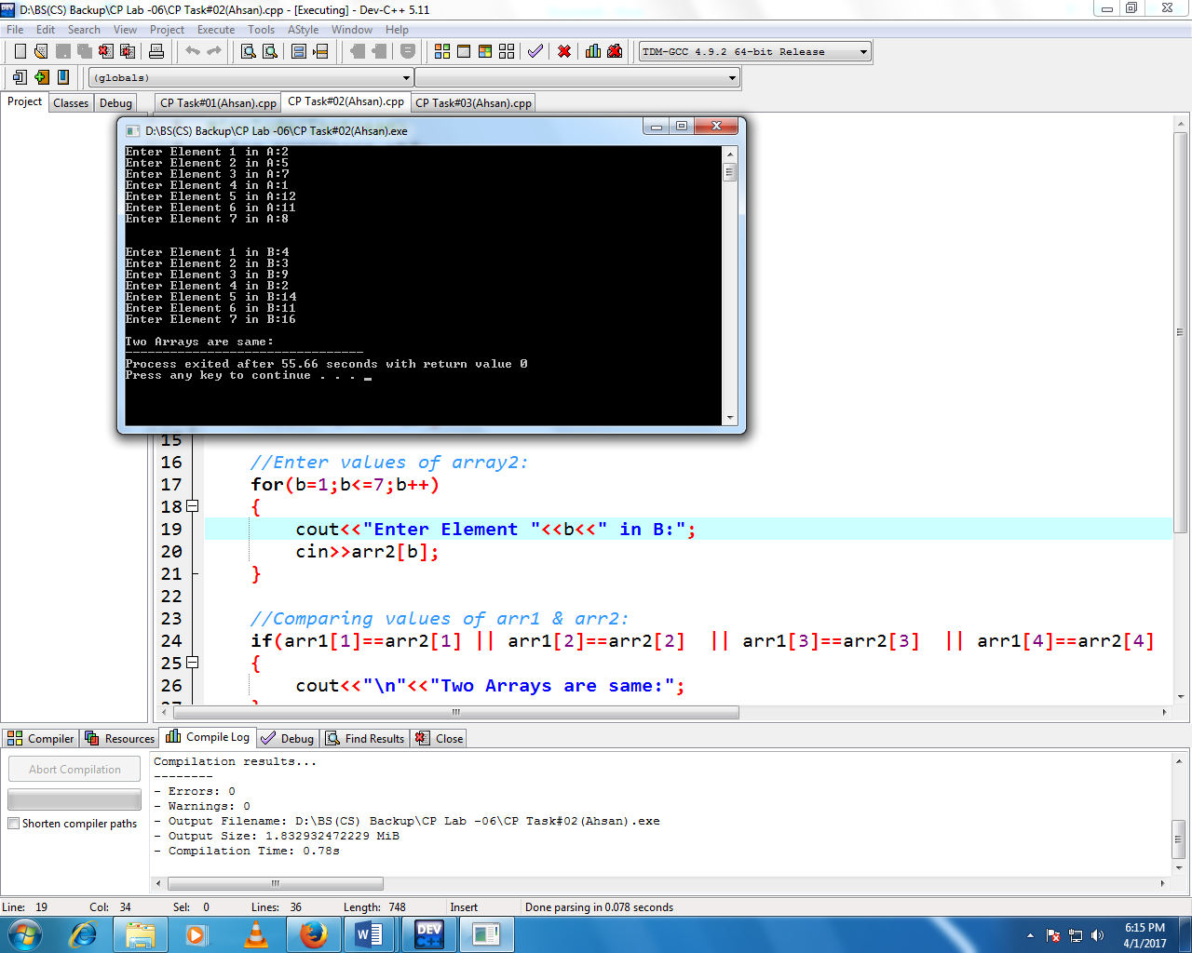

Exercise 3:

Write a C++ Program, ask user to enter 10 interger values. Display its data graphically by plotting each numeric value as a bar of asterisks (*) as shown in the diagram

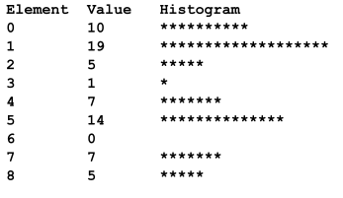

**SOURCE CODE:**

#include<iostream>

#include<iomanip>

using namespace std;

int main()

{

//Declaring Arrays:

int arr1[10],arr2[10],a,b;

//design an histogram on different values of array:

cout<<"Element"<<setw(13)<<"Value"<<setw(17)<<"Histogram"<<endl;

//apply nested for loop to enter values of array and print * on different value:

//of array to design a graph:

for(a=0;a<=9;a++)

{

cout<<a<<"\t"<<"\t";

cin>>arr1[a];

cout<<setw(29);

for(b=1;b<=arr1[a];b++)

{

cout<<"*";

}

cout<<"\n";

cout<<endl;

}

return 0;

}

**SCREENSHOT:**

